Charcoal Pet Portraits by Aimee Beyette
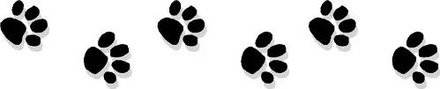

Order & Agreement Form

Client Name | Phone #
Address | E-mail address

Pet(s) Name | Breed/Mix
Portrait Size (mark with an X)
 | 9” x 12” | $140
 | 11” x 14” | $155
 | 12” x 16” | $170
 | 14” x 18” | $185
 | 16” x 20” | $200
Head only
Full body

Matting/Framing
 | Double matted | $15
 | Double matted + framed | $40

Delivery
* Cost will be determined based on order and will be included on your invoice.
** Will inform you whether I can deliver or meet you somewhere based on your location.
Small delivery fee may be added.

USPS *
Pick-up/ artist delivery
(Falls Church, VA) **

Special requests or comments
Please list specific deadlines

Gift Order
Yes
No

If yes, please provide recipient name & address if you would like shipped directly
How did you hear about me?

By signing and placing an order you agree to the following terms:
- I understand that Aimee Beyette retains ALL copyright and reproduction rights to the portrait.
- The artist cannot be held responsible for items lost or damaged during shipment.

Signature: Date:

Please email this completed order with a few good quality pet pictures to aimeebeyette@gmail.com. Upon review, Aimee will provide a confirmation email and invoice with detailed payment options (PayPal or check).

Thank you!

Aimee Beyette
aimeebeyette@gmail.com
(716) 794-1434
www.beyettepetportraits.com

